It’s That Time of Year to Join With our Fellow UUs!
KENTUCKIANA PRIDE PARADE AND FESTIVAL
Waterfront Park Big Four Lawn
June 17th , 2023
This is a family friendly event!*

Since 1995, All Peoples has been a supporter of the Fairness Campaign, and in 2000, our church became a UUA Welcoming Congregation, when we committed to engage in the spiritual practice of welcoming all, especially the LGBTQ community.

We are once again inviting All Peoples members and friends to join in support of the LGBTQ community by participating in the Kentuckiana Pride Festival, where people will celebrate with a parade, vendor marketplace, & entertainment. We wish to provide a safe event, so we will require all our members/friends to be fully vaccinated to participate and to wear masks during our events.

Please join us – here’s how to participate:

Saturday, June 17th (noon):

* Pride Parade for All Peoples and other UU Churches– Themed UU Float; Families welcomed and encouraged! Join All Peoples and other local UUs as we decorate our float and march in the Pride Parade!
- Please contact Rhonda Barnett at rhondabarnett11@gmail.com to participate and tell her how you want to participate:
1. walking or riding
2. Parade and Festival (we will attempt to coordinate car-pooling for these categories)
3. Coming early to assist in decorating our floats
4. Attending the Parade only (some people will not be able to come down early due to work).
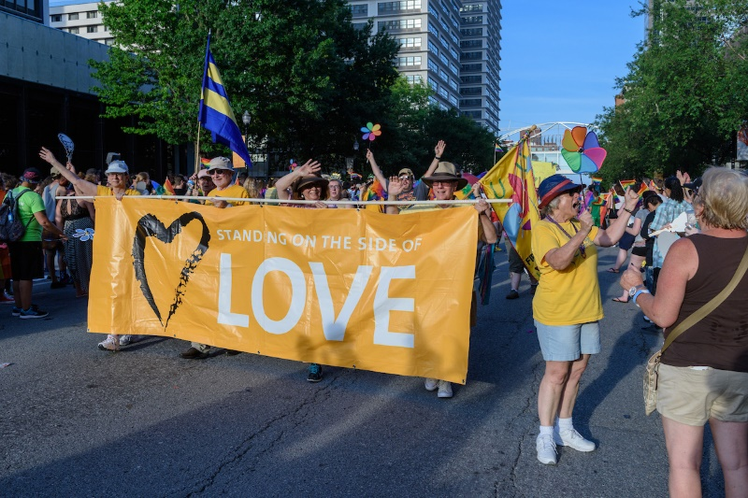
Rhonda will be in contact with those who are participating with details as we receive them!

SATURDAY, June 17th
* All Peoples Vendor Booth at the Pride Festival – Volunteers needed to staff our fun, innovative booth!
The Promotions and Social Justice Committee will host a booth to promote All Peoples by attracting thousands of visitors to our booth to find out more about our church’s values and our strong support of the LGBTQ community. A raffle for a huge discount for an LGBTQ wedding rental or any other celebration will be offered. All Peoples wheel of fortune and fun give-a-ways are a big hit!

* Fast Facts
- Dress for high visibility: Wear your All Peoples T-Shirts and Colorful Beads or other decorations! - 2 chairs and tables are provided under a canopy. Paid admission passes for you! Come early and enjoy the festival!
- Work a 3-hour shift with your friends or family using SignUp Genius to Pick your Shift!
- Please contact Ellen Wade, bigole@aol.com or 502-905-4408 to find out more info!

